

Outreach GDS Toolkit
Installation and User Guide

Toplevel Computing March 2015
Copyright ©2015 Toplevel Software Limited
Contents
Installing the GDS toolkit 3
Pre-requisites 3
Installation 3
Configuring a form to use the toolkit 5
General form settings 5
Form code 6
Declarations 6
Event handlers 7
User-defined functions 8
Utilising GDS toolkit features 9
Buttons 9
Help Text 11
Indented Headings 14
Field Validation 15
Summary 17
Summary set-up 17
Summary customisation 21

Installing the GDS toolkit

Pre-requisites
Before installing the GDS Toolkit, you will need to have a copy of Outreach Server 12.0.2.8 or higher and Outreach e-Form Designer installed on your server, as well as all associated pre-requisites. For further details, please see the Outreach Server Installation and Configuration Guide.

Installation
- Copy all files from the Static directory of the GDS Toolkit release into your Outreach Static directory (this should be located at C:\Program Files (x86)\OfficeForms\Server\Template\VirtualForm\Static).
- Copy OutreachGDSCustomStrings.htm from the Custom directory of the GDS Toolkit release into your Outreach Custom directory (this should be located at C:\Program Files (x86)\OfficeForms\Server\Template\VirtualForm\Custom).
- Copy OutreachGDS_repo.ofcodemodule from the OFServerForms directory of the GDS Toolkit release into your Outreach Active Forms directory (this should be located at C:\OFServerForms).
- Copy OutreachGDS.theme.xml from the Themes directory of the GDS Toolkit release into your Outreach Themes directory (this should be located at C:\OFServerWorking\Themes).
- Start (or restart) your Outreach server:
- Press Windows Key + R to open the Run prompt. Type in services.msc and click OK.
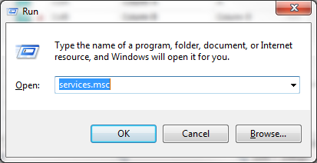
- In the Services window, scroll down until you find the OfficeForms Server service.
- Click the OfficeForms Server service and select either Start or Restart on the left sidebar.
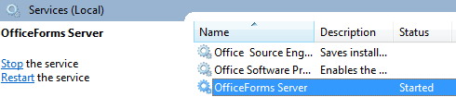

Configuring a form to use the toolkit

General form settings
- Open a new or existing form in Outreach e-Form Designer and go to Form Properties by double clicking the form icon in the top left of the field list.
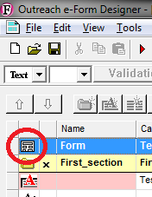
- In the General tab, under Appearance; Theme should be selected for Use. Change the Theme Name to OutreachGDS.
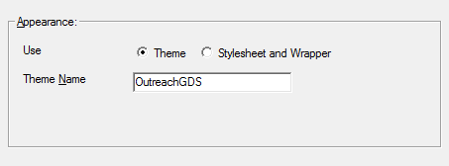

Form code
Open the Outreach Code Editor by navigating to Edit > Edit Form Code in the main menu. If you cannot find this option in the menu, go to Tools > Options and change the User Level to Developer.
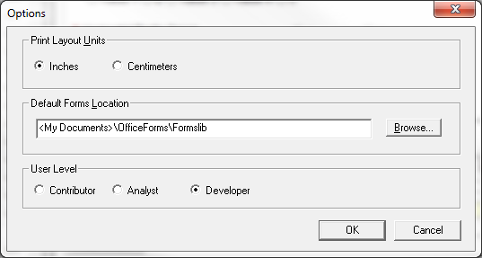

Declarations
Click on Declarations in the left sidebar:
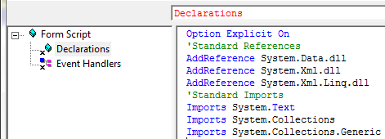

If the code below is not currently in Declarations, add it in:
Option Explicit On
'Standard References
AddReference System.Data.dll
AddReference System.Xml.dll
AddReference System.Xml.Linq.dll
'Standard Imports
Imports System.Text
Imports System.Collections
Imports System.Collections.Generic

Add the following lines to Declarations in the main window of the code editor:
Private Repo As Object
Dim ComponentCaptions As New Dictionary(Of String, String)

Event handlers
If they aren’t already displayed in your code editor, add the following event handlers:
- OnFirstLoadZCForm
- OnNewZCForm
- OnPresentSection
To do this, click the page icon above the main code window, choose Event Handler under Function Type and click OK.
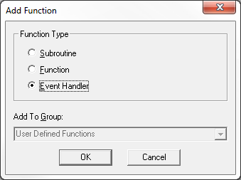
Choose the appropriate event handler and click OK, repeat until all event handlers have been added.
- Add the following code to OnFirstLoadZCForm:
If Not Outreach.CodeModuleLoad(Repo, "OutreachGDS_repo.ofcodemodule") Then
Form.ShowSystemError("Error", "Failed to load repo shared code module","","MEDIUM")
Form.EndModal("CANCEL")
Return
End If

ComponentCaptions = Repo.CaptionClone()
Repo.Summary("CAPTURE", ComponentCaptions)

- Add the following line to OnNewZCForm:
Repo.Init()

- Add the following line to OnPresentSection:
Repo.StepIndicator()

User-defined functions
Click the page icon above the main code window, choose Subroutine under Function Type and click OK.
This will create a new subroutine called NewSub1 (or similar). Above the main code window, you will see the subroutine name.
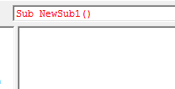
Change it to the following:
Sub Summary(action as String, Optional gotoSection as String = "")
In the main code window, add the following code:
If action = "EDIT" Then
Repo.Summary("EDIT", ComponentCaptions)
Else If action = "GOTO" Then
Form.CustomTokenSet("Summary", "")
Form.SectionSetNext(gotoSection)
End If

Utilising GDS toolkit features

Buttons
GDS Outreach forms can have three button types:
- Primary call-to-action
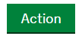
- Secondary actions
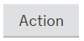
- Secondary toolbar & table actions
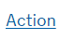
By default, a form configured to use the GDS toolkit will have a Continue button (equivalent to the Next button in default Outreach forms), Exit button and Back button (if there is a previous section to go back to) on the bottom toolbar.
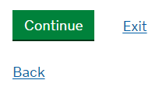
Additional buttons can be added to the toolbar, but it is the form designer’s responsibility to organise the order and layout of the toolbar through form code.
Each section should have a single primary call-to-action button. By default, this will be the Continue button shown above. However, the form designer can create their own primary call-to-action button by doing the following:
- Create a button element by adding a new field, navigating to the Field Data Properties and clicking the button icon in the General tab.
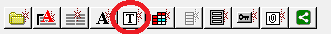
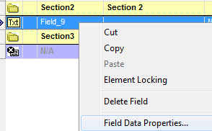
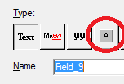
- Change the name of an existing or new button element, ensuring it ends with the suffix __pca.
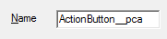
If creating a custom primary call-to-action button, it is recommended that the form designer hides the Continue button using the NavButtonShow command (see the Outreach Code Editor help for more information).
If a custom button does not have the __pca suffix, it will be styled as a secondary action button (or a secondary toolbar action button if Display on Toolbar is selected for the button).
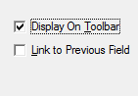

Similarly, a link button can be created by following the above steps, but adding the __link suffix instead of the __pca suffix.

Help Text
By default, fields with help text will have a help icon to the right, which opens a pop-up with the help text when clicked.
In order to utilise GDS-style help, a specific prefix needs to be added to the start of the help text. The available prefixes are as follows:

- Micro text (__micro:) – Available for both standard captions and caption over field.
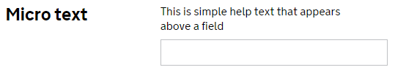
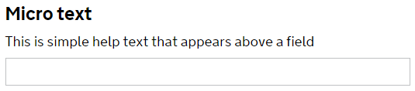

- Indented micro text (__indmicro:) – Available only for captions over field.
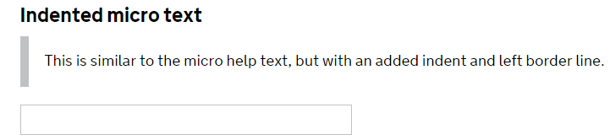
- Captioned dropdown (__drop:) – Available only for captions over field.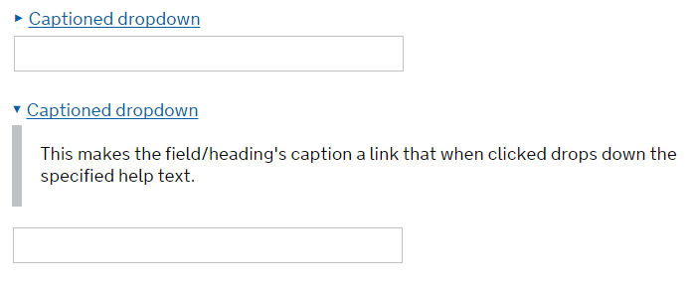

- Help dropdown (__help:) – Available only for captions over field. By default this will have the prompt text “Help”. This can be customised to have any prompt text by using a “||” separator in the __help tag:

__help: Help prompt||help text
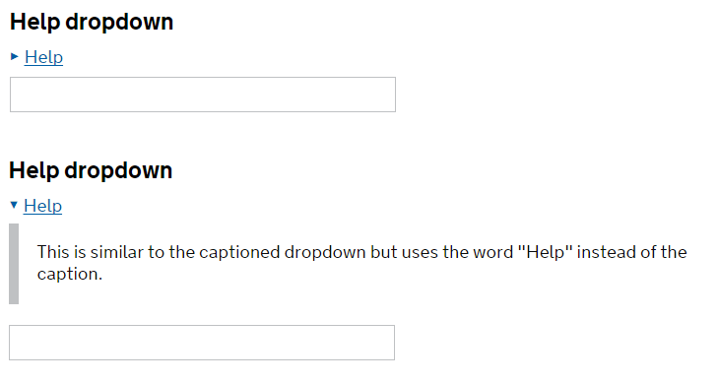
- Guidance text (__guidance:) – Available only for captions over field.
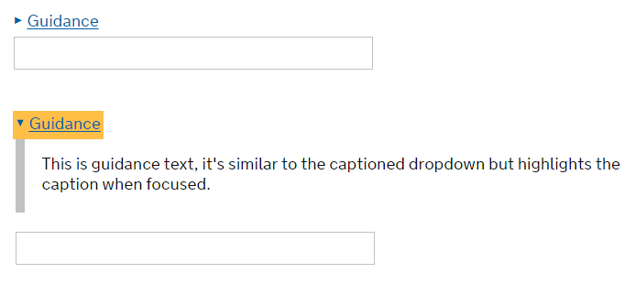
To add GDS-style help to a field, open its Field Data Properties and navigate to the Help and Captions tab. Choose one of the prefixes from above and add it to the beginning of your field’s help text. Note that if you have a field with a Standard Caption Layout and you add a prefix that is not compatible, the help text will not be displayed on the form. If there is no prefix, or Help Is URL is checked, the default Outreach help icon will be used.

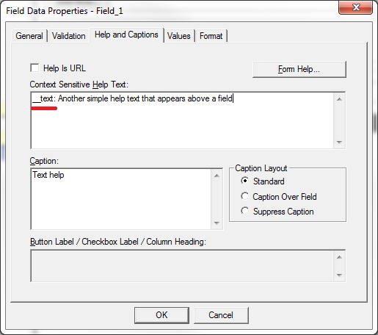

Indented Headings
Some GDS forms require content to stand out using indentation. In order to indent content, add a heading above all the fields and captions you wish to indent.
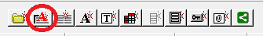
Then modify the name of the heading, ensuring it ends with the suffix __ind.
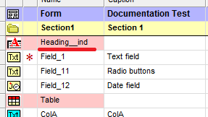
All fields and captions under that heading will now be indented.
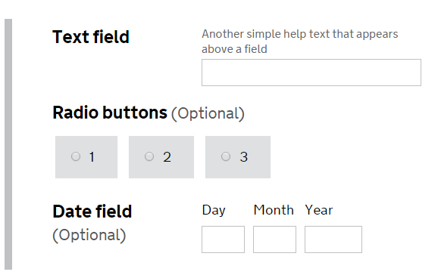

Field Validation
Field errors for a particular section are summarised at the top of the page. Each field error is clickable and will move focus to the field which requires attention. If a mandatory field has not been filled in, the default error text is “This is a required field and must be completed.”
This default text can be replaced with a reference to the specific field using a __mand: tag in the help text. This can be used alongside any of the other help text tags, the text of the __mand: tag will not show up in the help text, it will only be used for the mandatory field message.
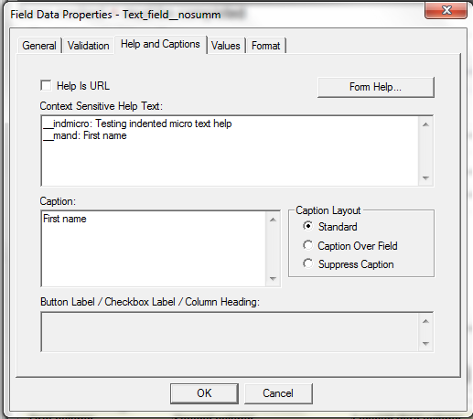
The above tag “__mand: First name” will result in the following error message if the field isn’t filled in:
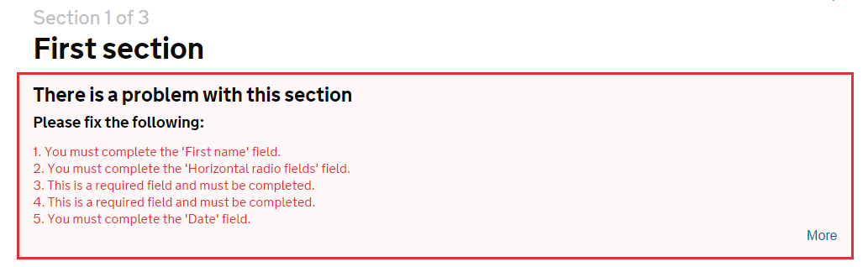

This error will also appear around the field in question:
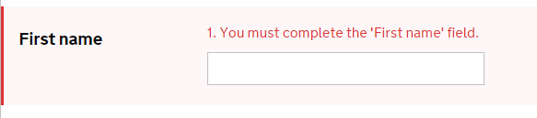

Summary

Summary set-up
The summary feature auto-generates a structured summary of the entire form’s fields and tables.
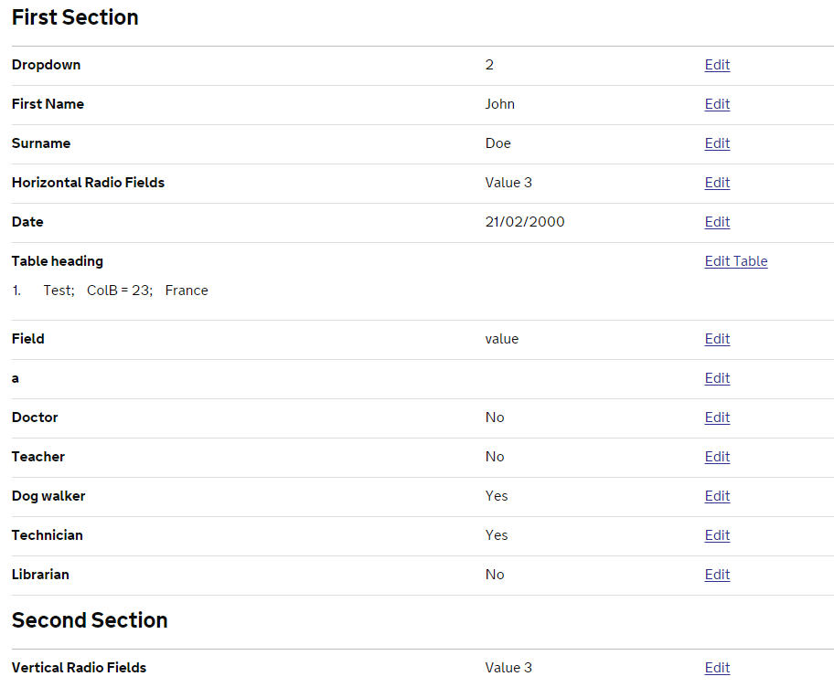
To use the summary feature, carry out the following steps:
- Create a summary section
Create a new section for the summary and give it a name (other than Summary). In our example, we have named it Summary_section.
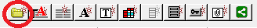
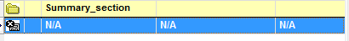
- Create a summary table
- Add a new table to this section and name it Summary. Set the Number of Columns to 7 and tick the Suppress Heading Text checkbox.
Note: The table must be named Summary for the summary feature to work.
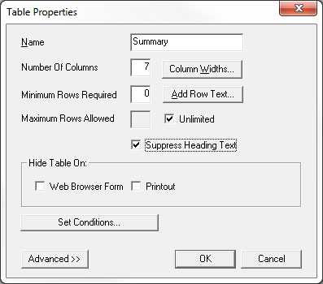
- Change the names of the columns to match the following names in order:
Caption, Name, Type, Value, Section, Action, Action_button
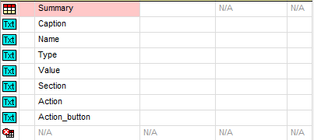
- Double-click the following columns and tick Web Browser Form under Hide Column On in the General tab:
Name, Type, Section, Action_button
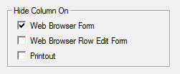
- Double-click the Action_button column and change it into a button.
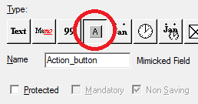
- Keeping the Field Data Properties window open, navigate to the Values tab and click Add…
Choose Call BASIC Function under Action Types and click OK.
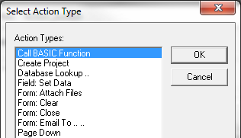
- Enter the following text next to Function Name and click OK:
Summary("EDIT","")
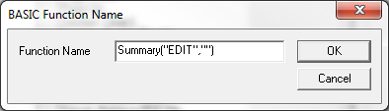
- Change the label for Action_button to ACTION.
Note: After creating the Summary table, it can be copied in pasted into other forms, rather than having to re-create it for every form.
- Update the OnPresentSection event handler
In the Outreach Code Editor, navigate to the OnPresentSection event handler that was added during the configuration of the form for use with the GDS toolkit. Add the following code:
Select sName
Case "Summary_section"
Repo.Summary("INIT", ComponentCaptions)
End Select

Replace Summary_section with the name of the section you used in step 1.
- Update form tables to work with Summary
In order for table data to be displayed in the summary, an extra Summary column has to be added to each table in the form.
- For each table, click on the bottom row of the table element and click the New Table Column icon.
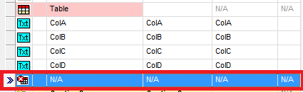
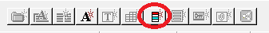
- Change the name of the new column to Summary and double click it to open the Field Data Properties dialog. Tick all three boxes under Hide Column On in the General tab. Note: the column must be named Summary for the table data to appear in the Summary section.
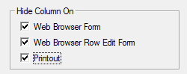
Repeat the above two steps for every table that you wish to display in the Summary section.
- Add Save & Back To Summary button
The summary section also includes an edit option next to each field and table in the summary. Clicking these will take you to the relevant section, replacing the Continue button with a Save & Back To Summary button. This replacement button needs to be added into the form.
Add a new button (add new field and change type to button) and change the name to Backtosummary. Note: The button must be named Backtosummary for correct functionality. Open the Field Data Properties and navigate to the Values tab. Click Add…, select Call BASIC Function and click OK. Enter the following code next to Function Name:
Summary("GOTO","Summary_section")
Replace Summary_section with the name of the section you chose in step 1 and click OK. Tick Display On Toolbar under the Format tab.
Change the Backtosummary button’s label to Save & Back To Summary, or any text that would be considered appropriate for the back to summary button.

Summary customisation
By default, the Summary feature will display all fields and table columns that are both enabled and visible. In some cases, you may wish to exclude some of these enabled and visible fields or columns from the summary. In order to do this, simply change the relevant item’s name to end with the suffix __nosumm.
That item will now never show in the summary, even if it’s visible and enabled.
Similarly, if you have a hidden or disabled field or column that you wish to display in the summary, change the relevant item’s name to end with the suffix __showsumm.

